This is the assignment of Git Integrating with Jenkins submitted by Mr. Aaditya Kulkarni

In this I created 3 repositories with index.html file for each,

After every build the index.html is executed while deleting workspace before every build.

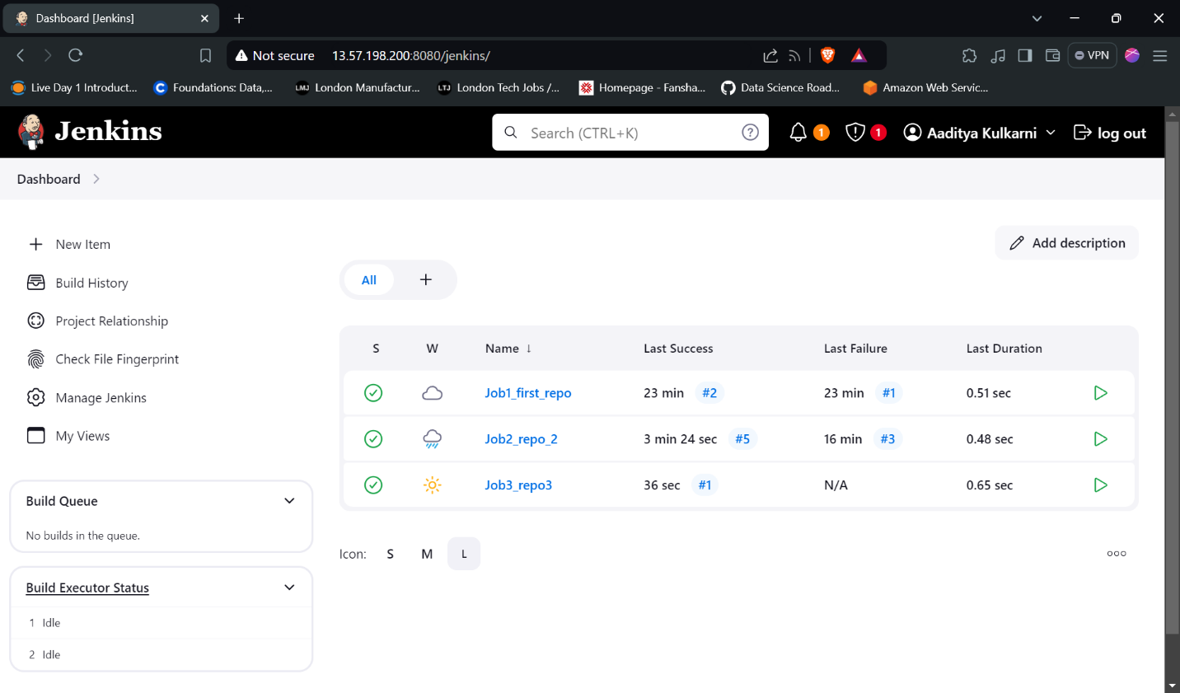

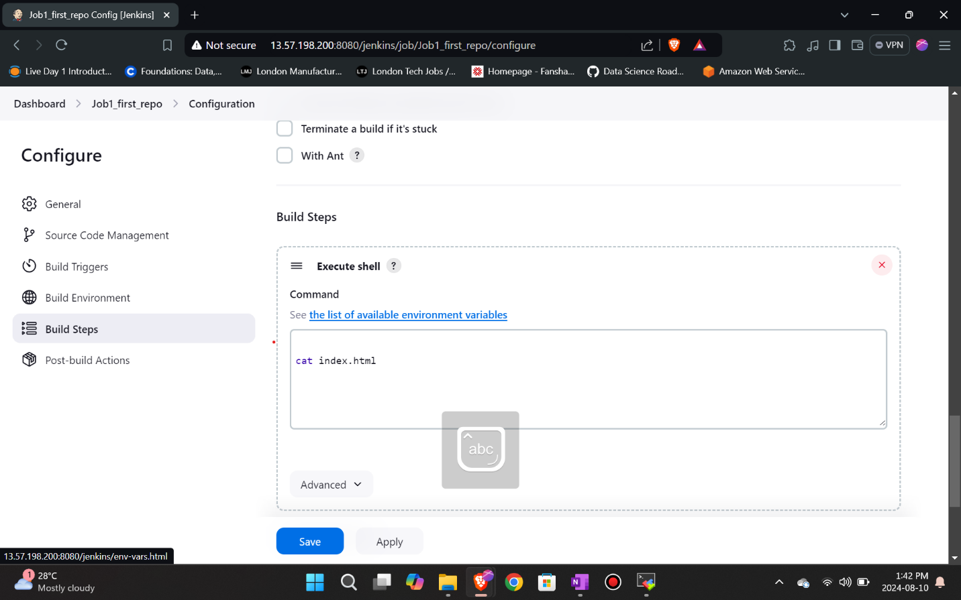

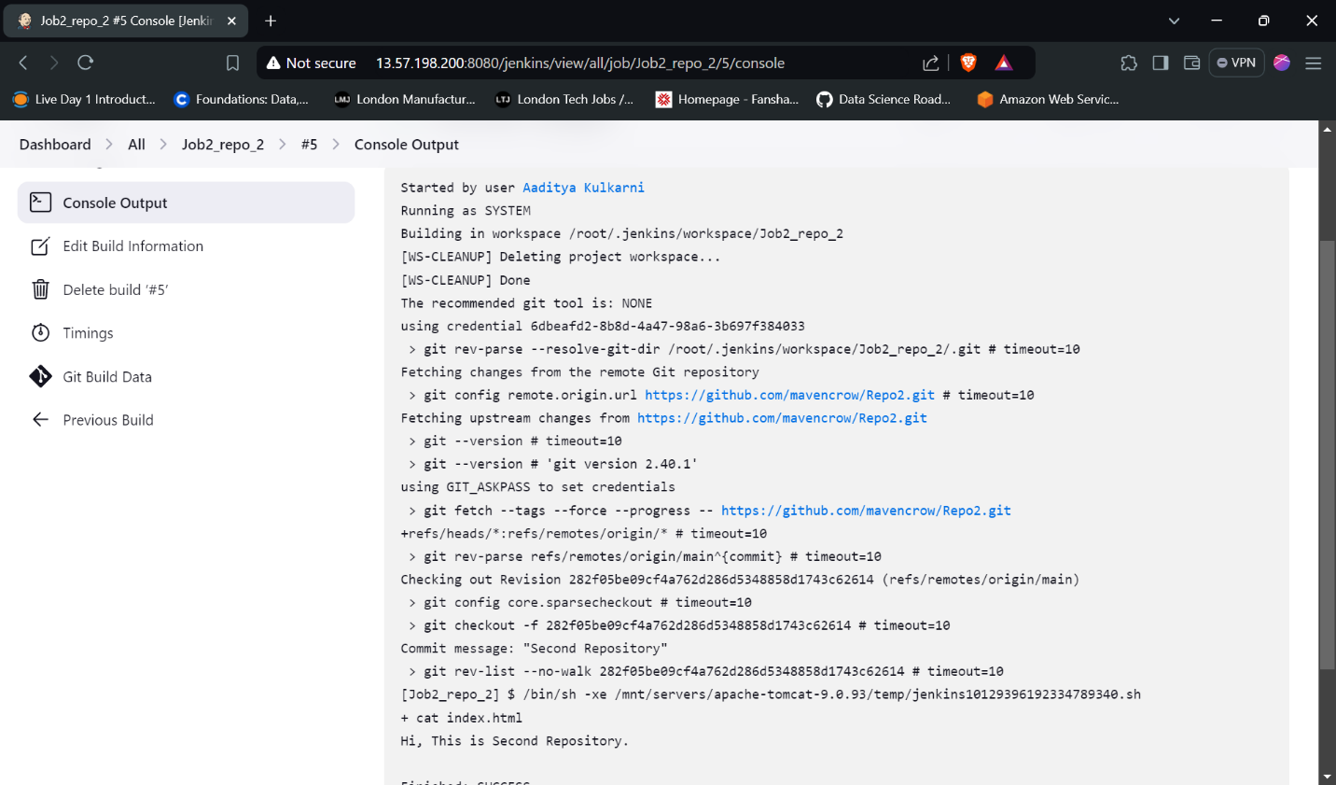s

